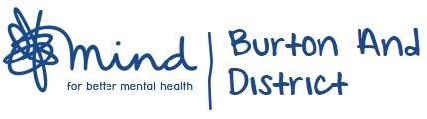

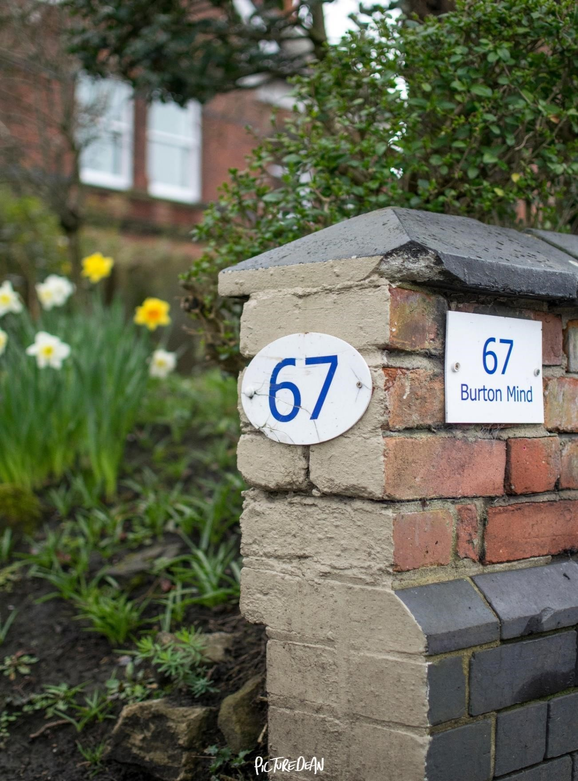
Annual General Meeting 16th Sept 2020

Our Vision - Is for everyone in our community to experience better mental health.

Our Mission – We provide advice and support to empower everyone to experience better mental health.

Our Values Service Quality Integrity
Client Focus
Inclusivity
Collaboration
Sustainability

What our clients comments this year
:

“
Every single session
helped immensely, I
feel as treat
ed like
an individual, thank
you”

“
Above and
beyond my
expectations
”

“
The service

I
received

has m
ade
such a difference to
how I see myself
,
thank you
”

“
I can’t thank my
counsellor enough, the
warmth and support
has
made me begin to feel like
the person I used to be
”

Such a welcoming,
safe environment, a
place I felt I could
open up and get to
the root of my
problems

AGM 2020 Index
- Chairman’s report
- Treasurer’s report
- Centre Manager’s report
- Deputy Manager’s report

Services
- Building Better Opportunities - Project Facilitator’s report
- CCG counselling project overview
- Trent and Dove Floating mental health service report
- Young person’s counselling service
- Thinkwell service
- Holistic Therapy report comments complete
- Relaxation Group report

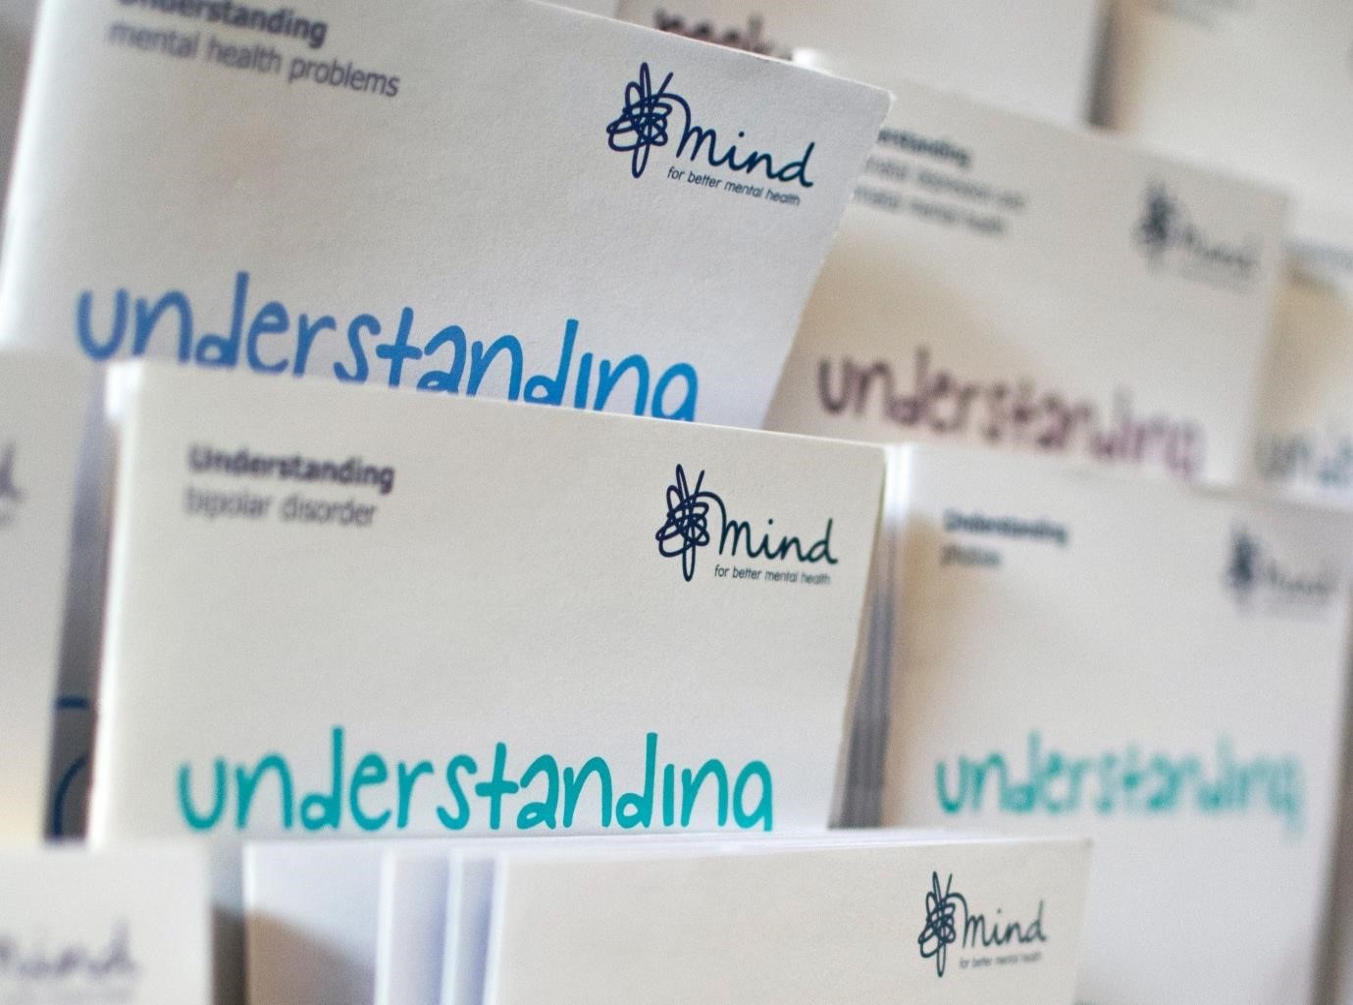

Chairs Report 2019/20

This has been a year of consolidation and preparation for the opportunities and challenges ahead. Much of our time and resources have been spent preparing and tendering successfully for the new Staffordshire Wellbeing Service Non-IAPT contract as a subcontractor to Midland Partnership. This will give us an amount of financial stability for the next 3-5 years, enabling us to access other funding opportunities going forward.

The new contract will mean changing the way we operate, this includes the employing of counsellors rather than being self-employed and client referrals will be via a single point of access through the MPFT contractor.

We have continued to meet our performance levels on all of our other contracts. This is due to the hard work, skills and commitment of our valued staff and counsellors. I would like to take this opportunity to offer grateful thanks to them, we are indebted to all concerned. At this point I offer sincere thanks to our Trustees, without which our progress over the past year would not have been as successful. Over the year we have regular monthly meetings. Items discussed include the Strategic, Business and Operational Plans, Mind Policies, Contract Performance and a regular updated skill audit to identify any potential any shortfall which may need to be addressed.

The end of this financial year has bought a new and scary new challenge, COVID 19. We have just begun National Lockdown and have ceased to operate face to face counselling and holistic therapies. Counselling is now being offered remotely via telephone, skype or Zoom. As always we are adaptable to challenges and changes, and we will continue to ensure that all clients’ mental and emotional needs are met.

Ken Builth – Burton and District Mind Chair of the Board of Directors

Treasurers Report
1 April 2019 to 31 March 2020
My last report looked forward more optimistically thanks to much hard work and determination by everyone during the year.
Burton and District Mind continues to face and respond to challenges with a large degree of success. We continue to seek opportunities to develop our range of services and work continues in this area. Our respect, standing and reputation in the surrounding areas continues to grow as a result.
I am pleased to report that due to continuing extensive effort by our team in finding and securing new funding streams and associated work, that we continue to establish our financial viability. I regularly reassess the level of our reserves fund, currently £30,000. At the same time the Unrestricted (General) Fund remains fairly constant at £32,924 compared to £44,971 in 2019, £46,571 in 2018, £51,946 in 2017, £38,791 in 2016, £30,563 in 2015 and £25,296 in 2014. There is also currently a further £27, 077 available for use by the Board in our Legacies and Fundraising Designated Funds.
Due to contractual changes our core Counselling funding is potentially more stable but continues to be subject to much discussion and scrutiny. With a strengthened Board membership good work continues to be done on keeping a close eye on our cash flow and seeking to identify new funding streams outside of our core counselling funding. We continue to seek to broaden our base to help secure our future in these changing times. We are continuing to develop our private counselling and holistic therapy model with moderate but promising use so far.
New funding streams are important to our future and I trust that success in our applications will continue to stabilise our finances even further. Much hard work lies ahead but this report brings a measured confidence for the immediate future.
I would like to pass on my personal thanks to the many people that have been part of the Burton and District Mind journey over the last year. A special mention here for Lynne who continues to help develop our services in an effort to help those whom she has a passion to support and also to Linda who does the day-to-day hands-on financial work making my role very much easier.
Well done everyone
Addendum
At the time of writing I have just learned that Linda as Finance Officer is taking early retirement. This role will be a hard act to follow for her future replacement. I wish Linda all the best for their future prosperity and happiness.
Chris Rimmer - Treasurer
22 May 2020

Centre Managers report 2019/20

We have had another busy year and once again the year has flown by.

Our counselling team have been working hard this year finalise the East Staffs CCG counselling contract, reducing our waiting list and ensuring that all our clients completed their treatment under this contract. In December 2019 we received confirmation that we had been successful in our part of the Staffordshire wide Wellbeing Service bid. From 1st April 2020 Burton Mind will be providing Non-IAPT counselling to East Staffordshire, and additionally Lichfield, Burntwood and Tamworth areas. In North Staffordshire this service will be provided by North Staffs Mind and The Dove Service which will provide bereavement counselling across Staffordshire. This contract will cover 36 months with the option of a further extension of 24 months. This development will allow us some stability for our service and to work more cohesively with North Staffs Mind. As a result of this new service Burton Mind will expand into neighbouring areas over the coming years and build upon our success in East Staffordshire. Burton Mind will develop further counselling services to compliment the new Wellbeing service and this will allow us to develop our current work and provide greater choice for local people.

We have continued to experience high demand for our Face2Face project for 16 to 18 year olds and we have begun to provide sessions at another senior school this year as well as providing counselling for a third year in of local schools and colleges in the area. Additionally, we were also one of nine other providers successful in the procurement process to continue the County Council EAP support through ThinkWell which will allow us to continue to provide counselling for Staffordshire County Council staff.

Zainera and Dene have provided a variety of Mental Health awareness training requests this year and have completed mental health awareness training with local employers, school and other settings. Additionally, we have provided Mental Health awareness training to Burton Albion staff as part of the EFL Mind partnership. It is really positive that these requests are becoming more frequent and we are able to raise awareness of mental wellbeing in our community and reduce stigma around mental health difficulties more widely.

Our holistic project continues with a new addition to the Burton Mind team as Lalita joined us following Maxine’s retirement after over 10 years in this post, the Holistic service has remained busy and continued to support clients on our counselling waiting list with the Holistic Therapy Treatments, and Dene has continued to provide weekly Relaxation/Mindfulness classes, both these additional support pathways are very popular and we know that this also helps our clients to be more at comfortable to commence their counselling as they progress through our services.

Our Trent and Dove floating mental health support project has also grown, and John has successfully supported tenants within their properties and enabled many to improve their home environments, reduce social isolation and increase their household incomes to better support their needs. As Trent and Dove have expanded their geographical footprint of social housing stock we will need to adapt to additional demands to support our clients over the coming years.

Amina continued to provide support for our client on the BBO project and has gone from strength to strength expanding upon her knowledge of the surrounding area and achieve really valuable outcomes with her clients. The BBO project has extended for a further period and will continue until mid-2022 which is really positive for our clients and the project.

Burton and District Mind were chosen as Charity of the year by Mr and Mrs Almond, local Mayor and Mayoress and this has resulted in considerable fundraising efforts, the promotion of our services and mental health awareness locally. Thank you so much for your incredible energy and effort.

I am truly privileged and honoured to work within such a committed and dedicated team of staff, counsellors, trustees and volunteers and supporters, thank you all for your hard work this year, what a team! thank you all very much.

Lynne Barrell – Centre Manager
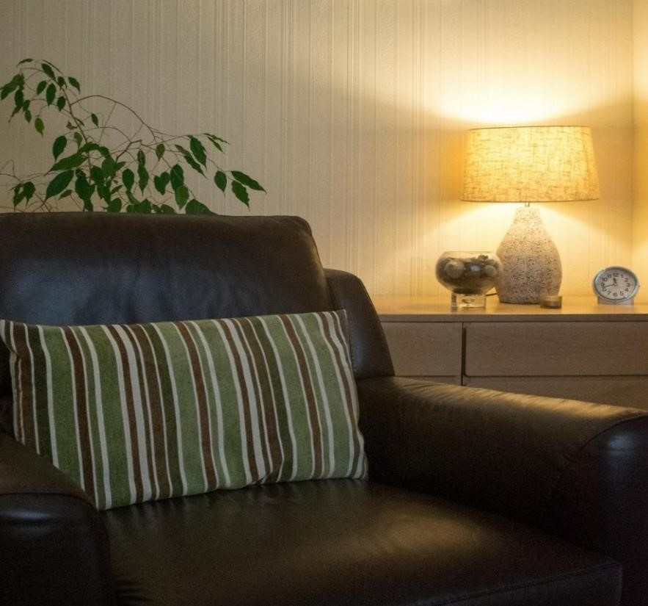

Deputy Manager’s report

Looking back over the last year our team have been busy with various events, training and fundraising taking place across our area. We have been finalising our ESCCG counselling contract this year which concluded on 31st March. A big ‘thank you’ to the team for all their hard work, dedication and support during this period, all our clients on the waiting list were seen efficiently and with the highest quality of care. We achieved all our targets for this contact and we were in a really good position to start as a sub-contractor to Midlands Partnership Foundation Trust on the new Staffordshire Wellbeing Service from 1st April.

With the end of this long standing counselling contract we have seen changes to our team with some counsellors leaving our team while others chose to work on our other counselling contracts rather than on the new Wellbeing service. The new opportunity has seen us work with the MPFT since December to develop the Non IAPT counselling services alongside the IAPT services. Burton and District Mind will expand our work into Tamworth, Lichfield and Burntwood as well as East Staffordshire, while the other partners will cover the other areas of Staffordshire. This new working alliance will see us collaborate as sub-contractors with the Dove service and North Staffs Mind as we all provide the Non IAPT Counselling while the Wellbeing team provide the IAPT across Staffordshire.

Due to the partnership of National Mind and the EFL, we have had an opportunity to provide our local football club Burton Albion with mental health training which was well received by the staff and the players and encouraged them to be open to explore their own mental health and learn more regarding their wellbeing. Alongside this training we also provided mental health awareness to local companies as well as local schools, which has seen us gain some fundraising donations from organisations such as Thermo Fisher Scientific, Morrison’s, Moseley School, Burton Rotary club and others. During December a group of us supported the Rotary club with their annual Santa pull around Burton, it was a very cold wet night when we put on our Santa hats to help collect donations for Santa, but we had a good evening along with other local charities collecting for the club.

It truly has been an eventful year with many changes and new opportunities on the horizon, which will hopefully see us expand our mental health support into other avenues. I am excited to see what the future holds and pleased to be a part of it.

Zainera Liaqat – Deputy Manager

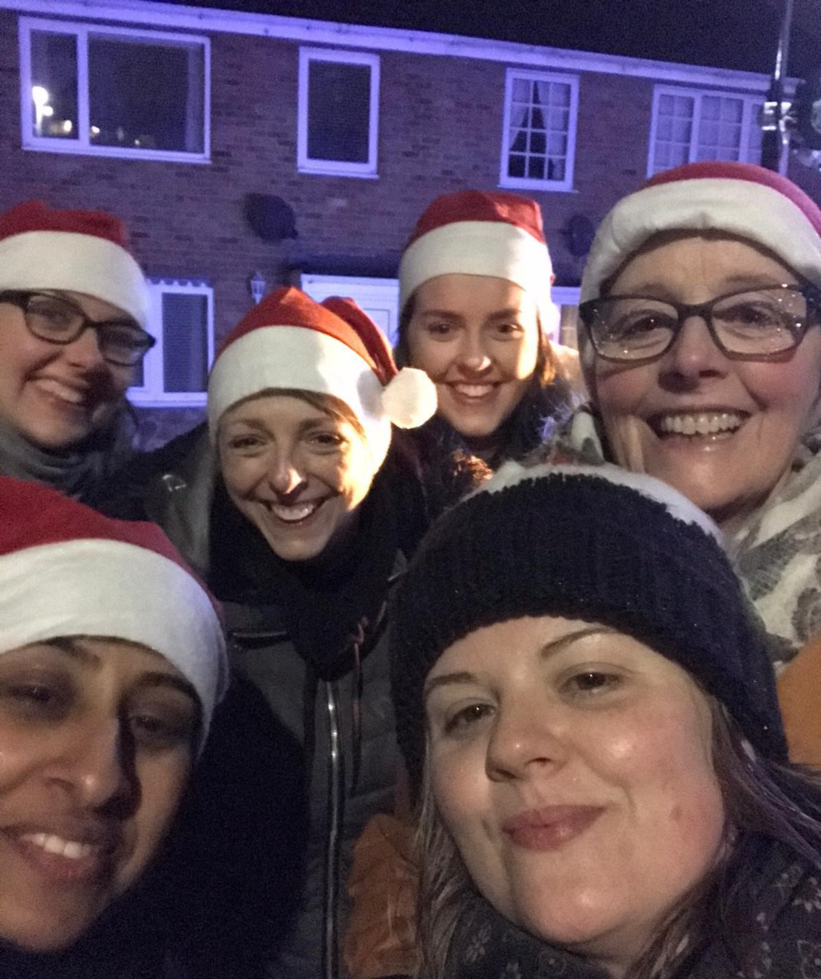

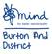

Building Better Opportunities report

The BBO project supports clients overcome barriers to employment, by improving their mental and social wellbeing through one to one support, relaxation and mindfulness and eco-therapy classes. Once the client feels ready, they then move onto employability training where they get support with CV, how to do job search, look at volunteer or work experience opportunities, interview skills training, look at courses to enhance job skills. All this can help clients improve their confidence, increase their self-esteem, reduce anxiety, depression, become more motivated and independent.
Amina has continued to provide support for our clients on the BBO project and has gone from strength to strength expanding upon her knowledge of the surrounding area and achieve really valuable outcomes with her clients. This year the BBO project has been extended for a further period and will continue until mid-2022 which is really positive for our clients and the project.

"…With help from Burton Mind and its professional staff, I was confident enough to start looking for local jobs and felt informed on the resources and training available which could develop my skills and update my C.V and help me to search for work. This ended with me enrolling with a local recruitment agency and employed locally, thanks to everyone at Burton Mind... "

“...What brought me to Burton Mind was my loneliness and not wanting to be part of the modern world. So the help on computer has been magical... Now I have stepped back in to life with a job I am good at. I will give it my best shot. The help I have received from Burton Mind has been a life saver. Thank you doesn’t even cover it...”
Amina Miah – BBO project facilitator

Counselling

Another year has passed and it has been definitely an eventful one. There has been a change in our counselling funding as we will now form part of the Staffordshire Wellbeing Service and self-referrals will be conducted through a single point of access. This change in contract will allow Burton Mind to branch into additional areas including Lichfield, Burntwood and Tamworth. Our counselling team remain dedicated to the Mind ethos and deliver our counselling services accordingly and we are very proud of the progress made by our clients.

However, 2020 has bought the Covid - 19 virus into our lives, this event has been a major wakeup call I'm sure you will agree. All counselling has been offered by telephone, Zoom or Skype since the National Lockdown was announced. This has allowed us to continue support for our clients during this period. Challenging times but Mind is, as always resilient standing strong, empathic to and responding to peoples' needs within our community.

As well as Burton Mind joining with the Staffordshire Wellbeing Service we have also continued to have counsellors working within the Thinkwell Project, Children in Need and providing support to Low-cost, Private counselling clients and free sessions provided by our in-training placement colleagues.

Earlier this year two members of our counselling team have moved on and we wish Racheal and Pam the very best in all they do. We have a dedicated diverse team that will continue to deliver our very best service during and beyond these challenging times.
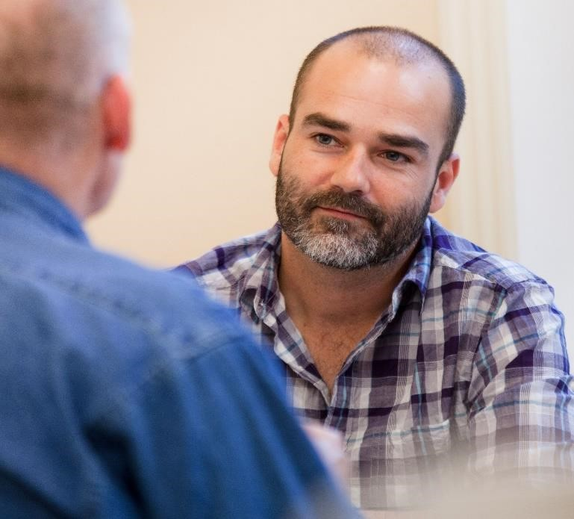
Yvonne – Counselling Team

Floating Mental Health Support Worker 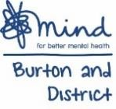

During the year I have successfully supported tenants within their properties and enabled many to improve their home environments, reduce social isolation and increase their household incomes to better support their needs.

The Floating Mental Health Support Service has supported 82 individual clients in the last 12 months.

I have supported tenants to claim £4,364.00 In housing benefit back date or Discretionary Housing Payments, plus supported a number of clients with benefit tribunals, to challenge DWP decision on benefit claims, with positive outcomes for clients. A total of £5,438.00 in funds had been secured via charity grants, to enable clients to buy essential furniture items, white goods and carpet their properties.

I have assisted a number of clients to move in to more appropriate accommodation, to improve their living conditions, due to mobility and health related issues.

One client has successfully moved from a large property into the flat at one of the local older people's shelter scheme. Enabling him to manage a much smaller property and the opportunity to gain social contact with other residents at the scheme and reduce his isolation.

I have sign-posted clients to seek support from other appropriate agencies and gain support from social services when personal care was required to improve their quality of support and care. This year I have worked with the Eaton Foundation, Together UK, Changes, the Community Mental Health team, Burton Albion Community Trust and numerous other groups.

As Trent and Dove have over recent years begun expanded their geographical footprint of social housing stock, further difficulties will be compounded by the current Covid-19 situation which will bring with it a new set of challenges. We will as ever continue to adapt to any new challenges and additional needs of our clients within this service and the wider community.

John Holt – Floating mental Health Support Worker

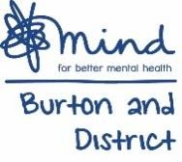

Young Peoples Project

We have been very fortunate to gain some more funding for the young person’s project and not just continue the counselling that we were providing at Burton College but also expand into schools such as Deferrers, Paget, Paulet and also John Taylor high schools.

This has allowed us to not only provide counselling in these schools but also provide mindfulness and relaxation classes to student who may not have been accessing the counselling, so allowing us to reach a wider audience of students to provide mental wellbeing to help them with their stress and anxiety that they may suffer with during their exam periods.

We were able to provide counselling at these locations with one of our qualified counsellors who were based on school property and were able to see students in school time, this enabled easier access to counselling for young people as they may sometimes struggle with attending our base due to school commitments or travel issues. The support has been well received by teachers and students with an increase in referrals from the schools and interest and bookings of mindfulness classes from them.

We had to respond to the Covid response and have had to delay the face to face counselling support that we were providing in schools but we have been able to provide some of this support remotely via phone and zoom with those students who were able to engage. We hope to continue this support face to face as and when we are able.
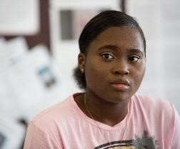

Zainera

Thinkwell
The County Council Thinkwell Support has continued to provide steady work for our counselling team this year. Burton Mind have provided employment support for County Council employees and manager referrals through provision of both counselling and CBT. We have continued to support a broad spectrum of County Council employees and have further responded to additional needs due to Covid-19 and the subsequent difficulties this has caused within statutory services.
Lynne

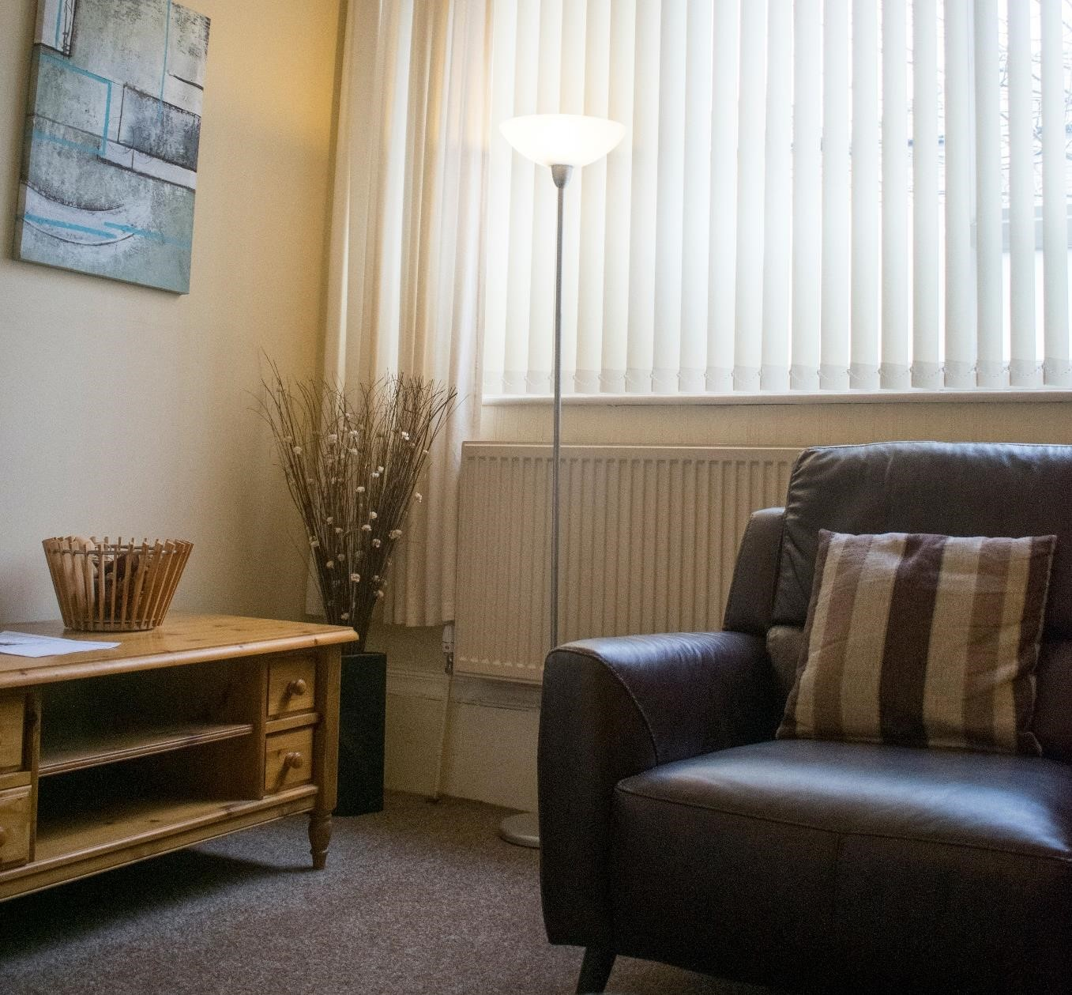

Holistic Therapy
From October 2019 until March 2020 thirty minute sessions of Holistic Therapies including Swedish massage, Indian head massage, seated chair massage and mini facials (which are a new addition to the Holistic service) were provided to our clients on Tuesday and Thursday mornings. The majority of my clients were either already attending counselling sessions or on a waiting list for a counsellor to become available.
The clients I saw were of differing ages and ethnicities and genuinely appeared to benefit from their treatments. All clients complete an evaluation and they commented on how appreciative they were of the service, how comfortable they felt and how deeply relaxed they became in a such a short space of time. My clients completed evaluation forms of which gave 100% positive feedback about the treatment they had selected to try. A few had never experienced holistic therapies before and really felt the benefit of engaging with a hands on therapy as well as counselling. The treatments allowed them the space and time to focus on themselves (all realising how important self-care is), and left feeling better able to manage and cope with life’s trials and tribulations. This was proven as I had many returning clients who were more than happy to pay more than the minimum monetary contribution once their free sessions were complete.
I feel very blessed to work in such a positive therapeutic environment and know that the service will continue to thrive in the future.

Lalita – Holistic therapist
“Absolutely amazing
holistic therapy
treatment, I feel so
relaxed
and calm”.

Thank you

“Excellent service,
Lalita helped me
feel much less
anxious, perfect”

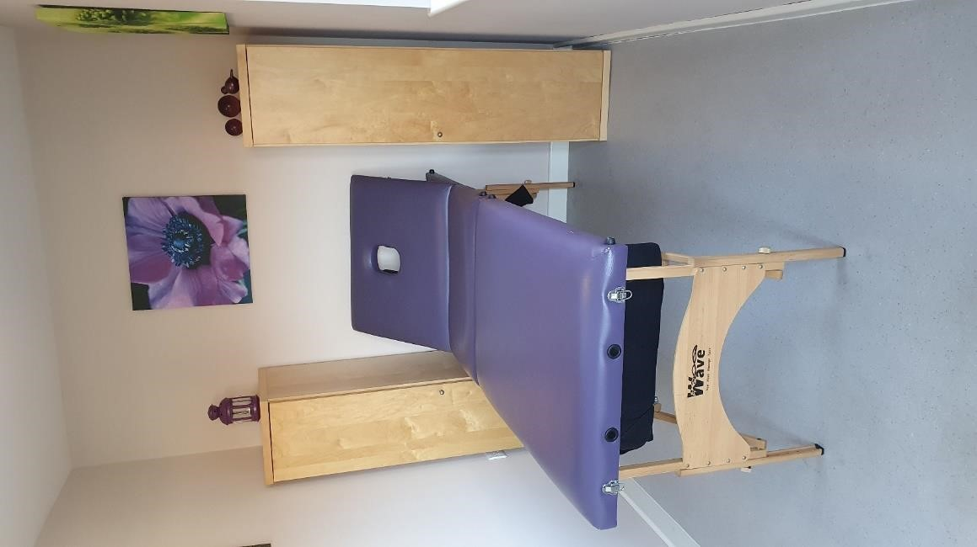
The Holistic therapy room

Relaxation/Mindfulness Classes

During this year we have made some changes to the Relaxation and Mindfulness group and listened to feedback from our service users, we relocated the class to our base in Branston Road and this has enabled more people access to the group in a familiar and comfortable setting.

This move has helped to increase the number of people accessing the class and has allowed us some flexibility to use different rooms onsite to accommodate mobility needs. I have also adapted the class to make the most of our sensory garden to give a different Mindful experience. However, we have maintained small groups as this helps the clients feel comfortable in the sessions and enable them express their emotions.

We have trialled and successfully incorporated creative therapy workshops as an additional relaxation activity. This activity helps clients to explore their thoughts and feelings creatively with the use of art materials which was positively re by the clients involved.

Our relaxation, mindfulness and creative classes have proven to be a useful addition to support our clients, while they wait for counselling. These projects help them to engage with their counselling sessions better, they are able to attend more frequently and their knowledge of self-care and self-awareness is increased which helps aid their recovery.

Many participants have experienced a profound change to their wellbeing and are surprised how easy this was to achieve, and state that they continue to use these techniques outside of these sessions.

We paused the group in March 2020 due to Covid-19 and hope to develop an Eco therapy aspect to our services in the coming months.

Dene (Relaxation group facilitator and counsellor)

